Other Support Tool
Full introduction/Instructions:
https://researchservices.upenn.edu/using-penns-other-support-tool/

For the Other Support Tool to effectively work Pi’s must:
- Update profile in PennERA to include eRA Commons ID
- Complete a brief description in the PI Certification at the time of submission. This will auto fill the Major Goals on the Other Support.



Login using Pennkey ID and password:
https://apps.research.upenn.edu/login

Select Grants & Contracts/Current & Pending Management:
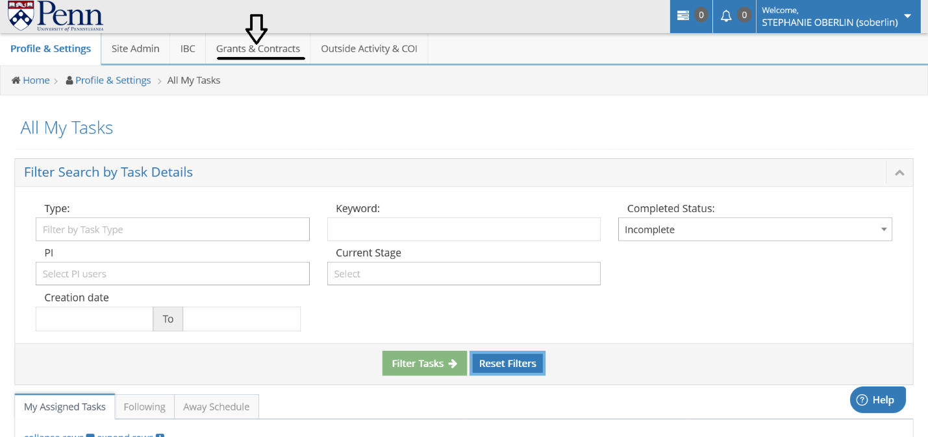

Select Researcher from drop down menu (begin typing to see list):
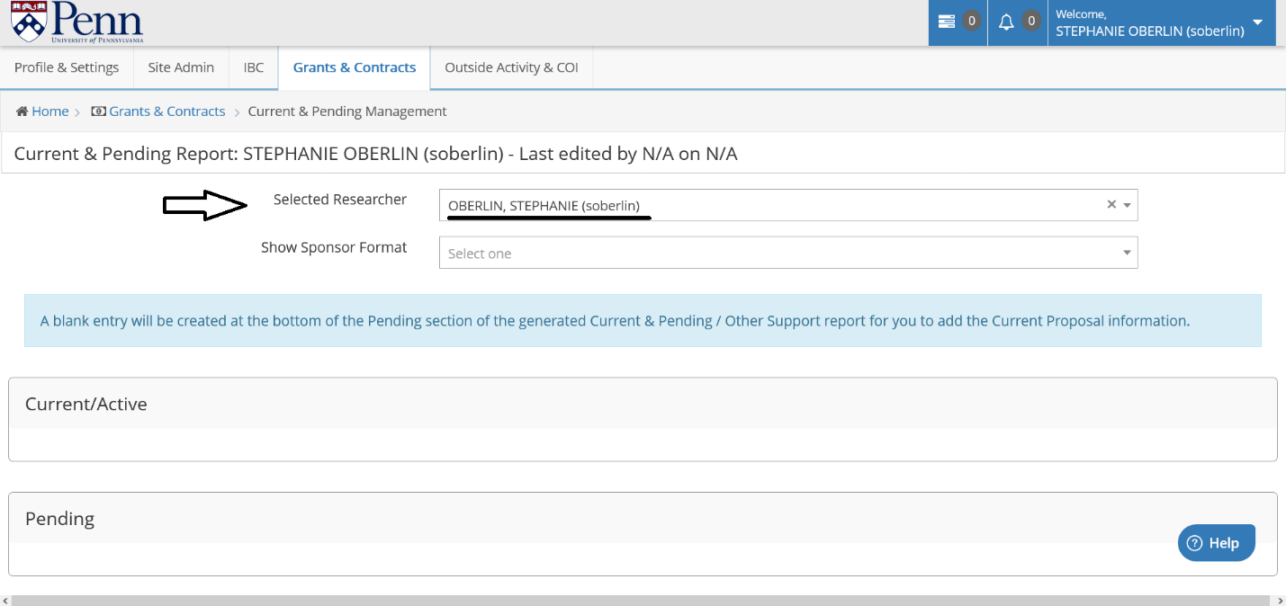

Select Sponsor Format from drop down menu:
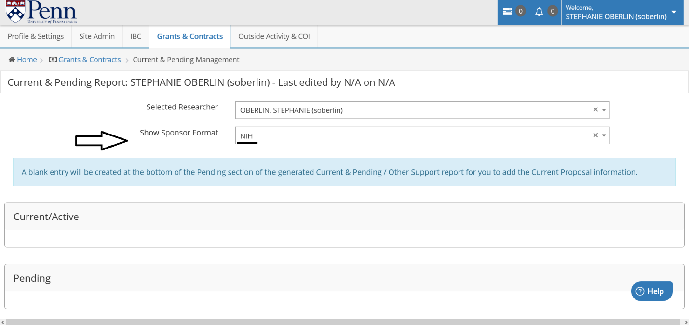

Scroll down and select applicable projects to include on your Other Support from the following sections – Current/Active, Pending, Previous Five Years (DOD), & Other Sources of Support (Reporting of active In-Kind contributions is required):
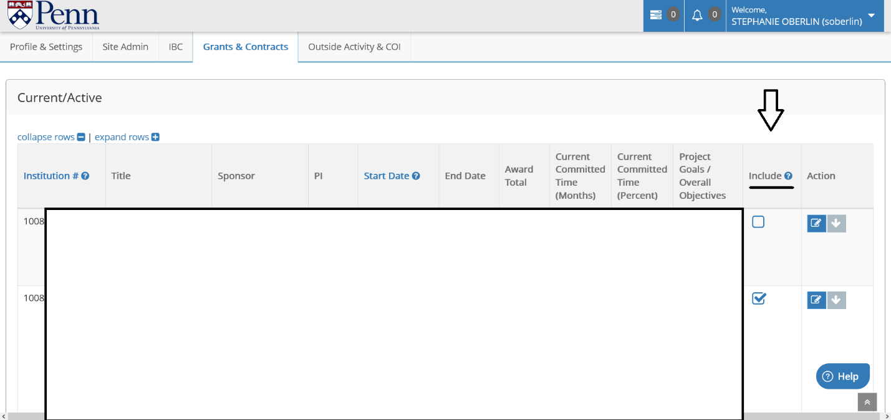

Use the Action button to make changes to active awards. *Please note that changes can only be made in the system if an award is active in PennERA* If an award is not active in our system (Ie. Amendment agreement has not be executed), changes must be made after the report is exported.
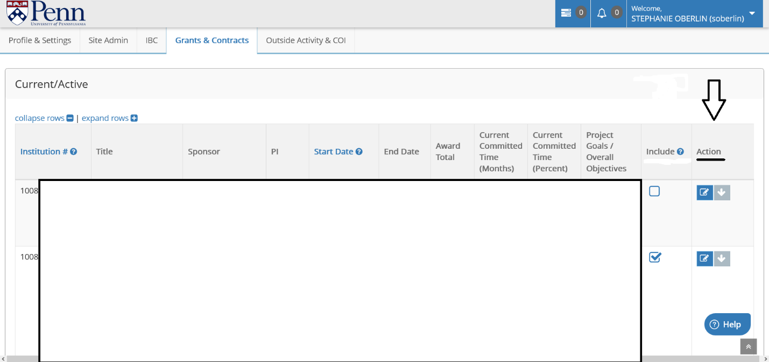

Other Sources of Support, including internal awards and in-kind are manually entered:
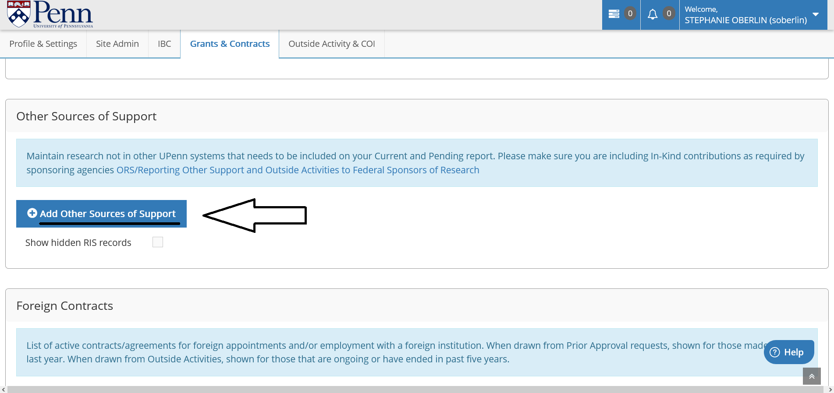

Save changes before exiting pop-up screens:
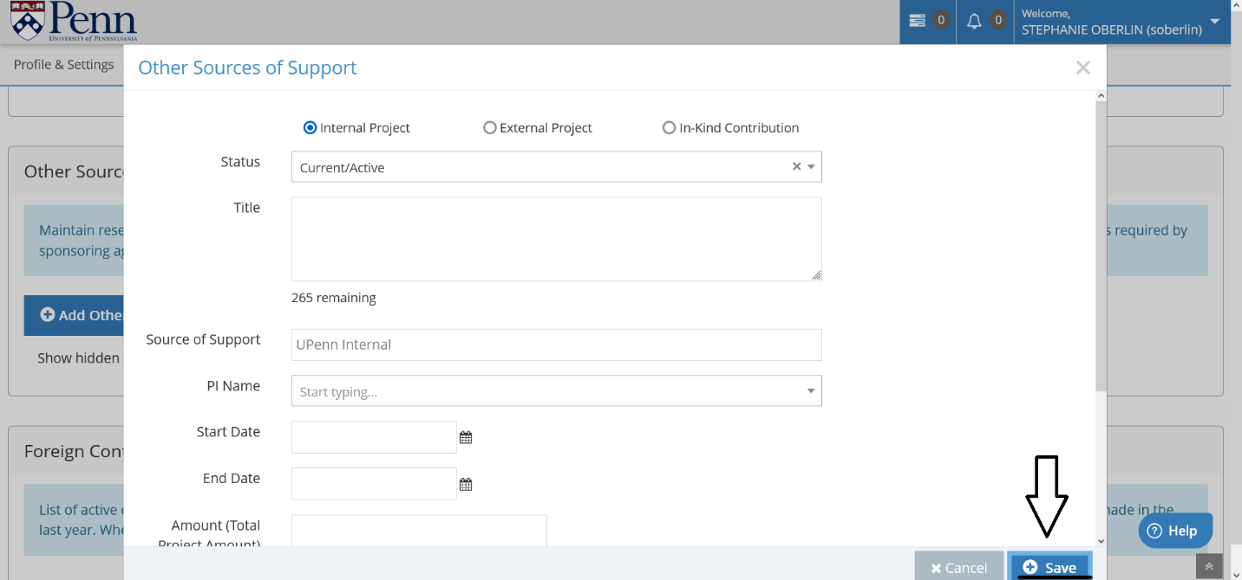

Print Report
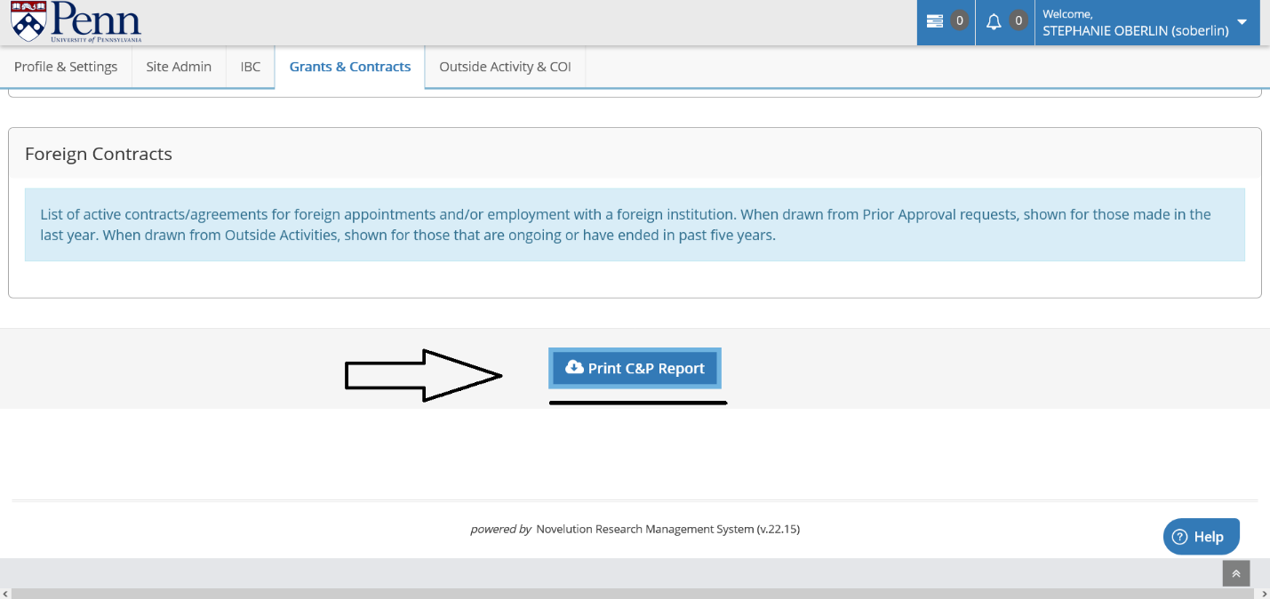

Review the downloaded report and make any adjustments needed to the final Other Support.

